Contents

Name the Tools/Frameworks? 2

Name the software Methodology? 6

Name the test design techniques below? 9

Name the activities: 12

Testing Types: 15

Name the Design Patterns: 18

OOPS Concepts 21

Think Security Testing Terms: 24

# Name the Tools/Frameworks?

1. 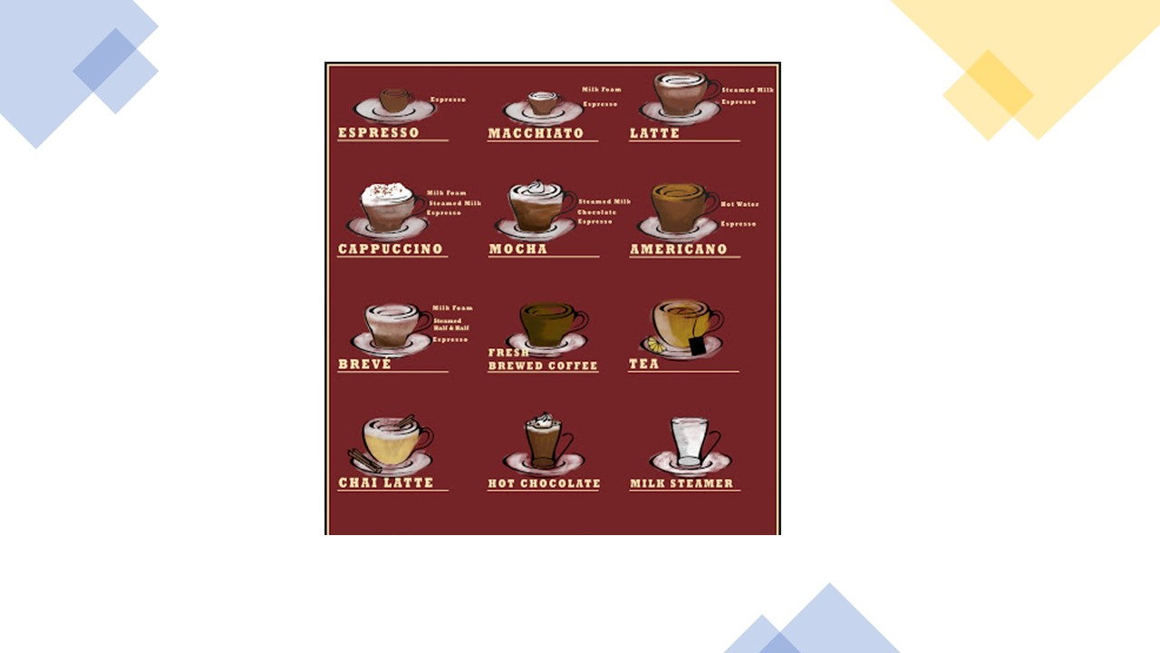

Answer : Mocha and Espresso

1. 

Answer : Jmeter

1. 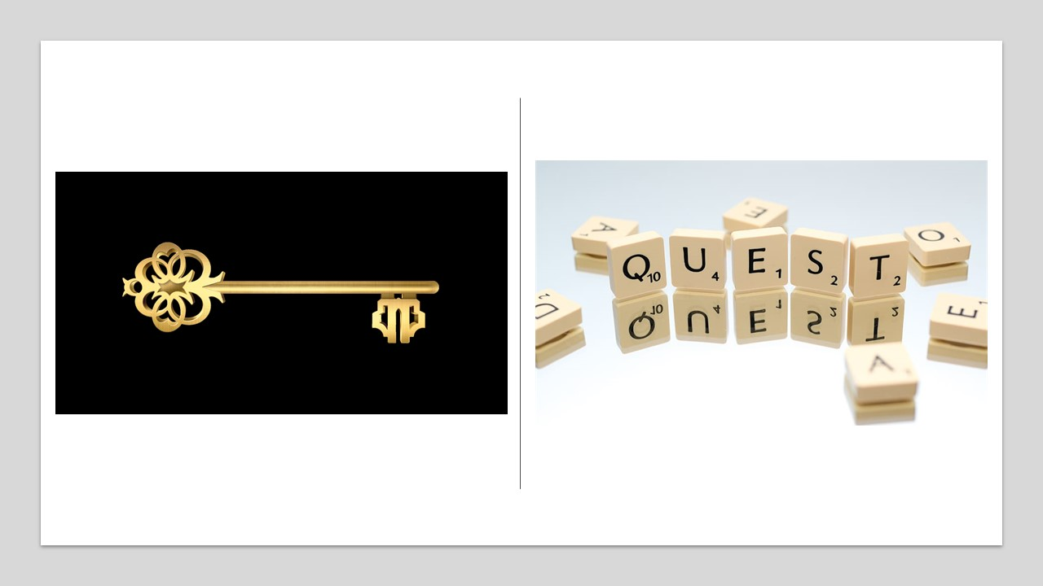

Answer : Keyword-Driven Framework

# Name the software Methodology?

1. 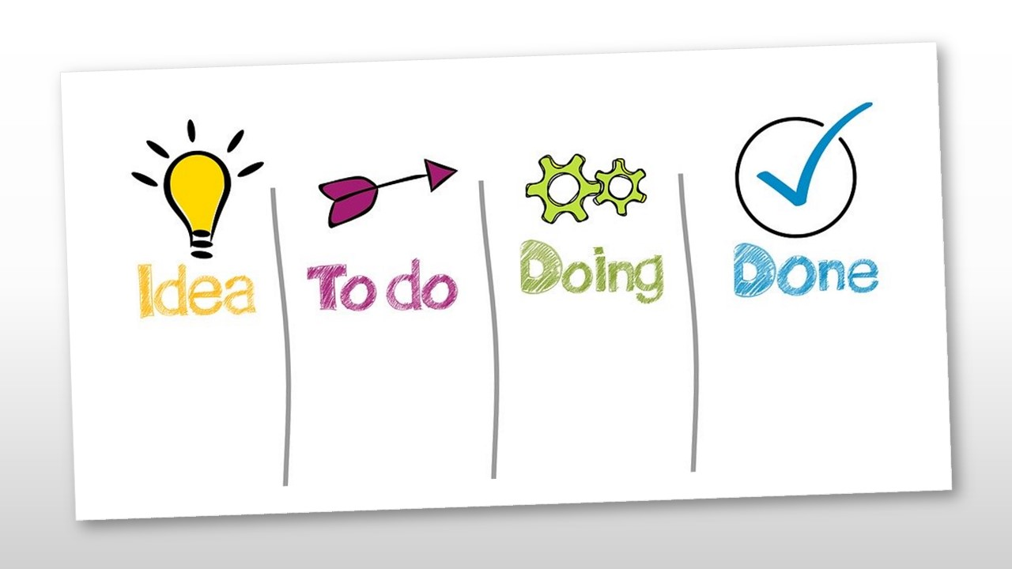

Answer : Kanban

1. 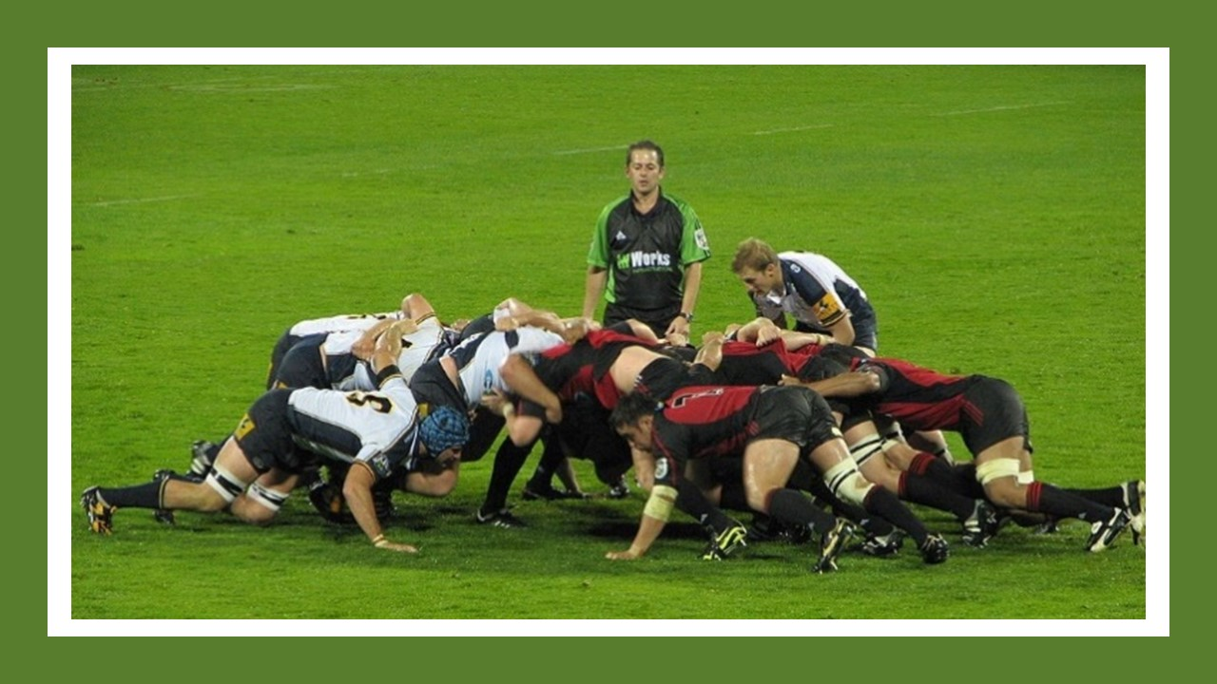

Answer : Scrum

1. 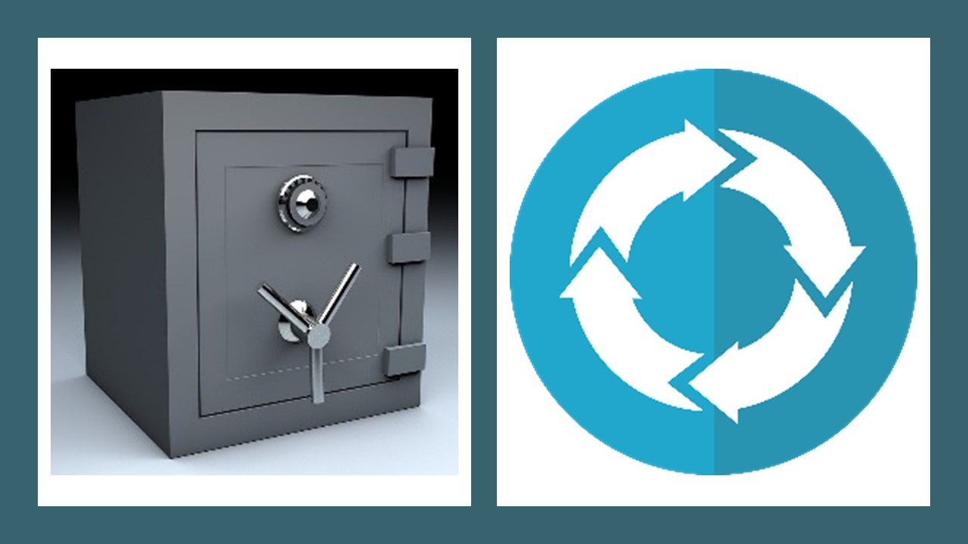

Answer : Safe Agile

# Name the test design techniques below?

1. 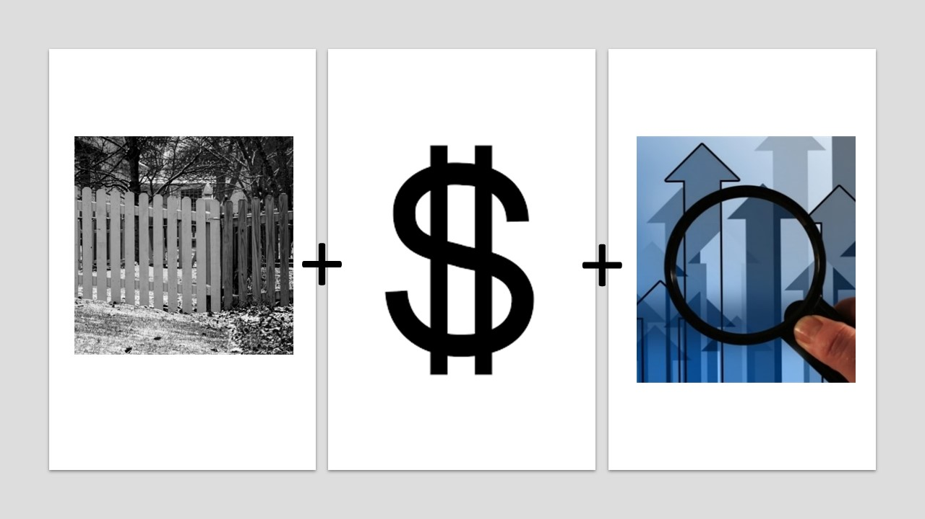

Answer : Boundary Value Analysis

1. 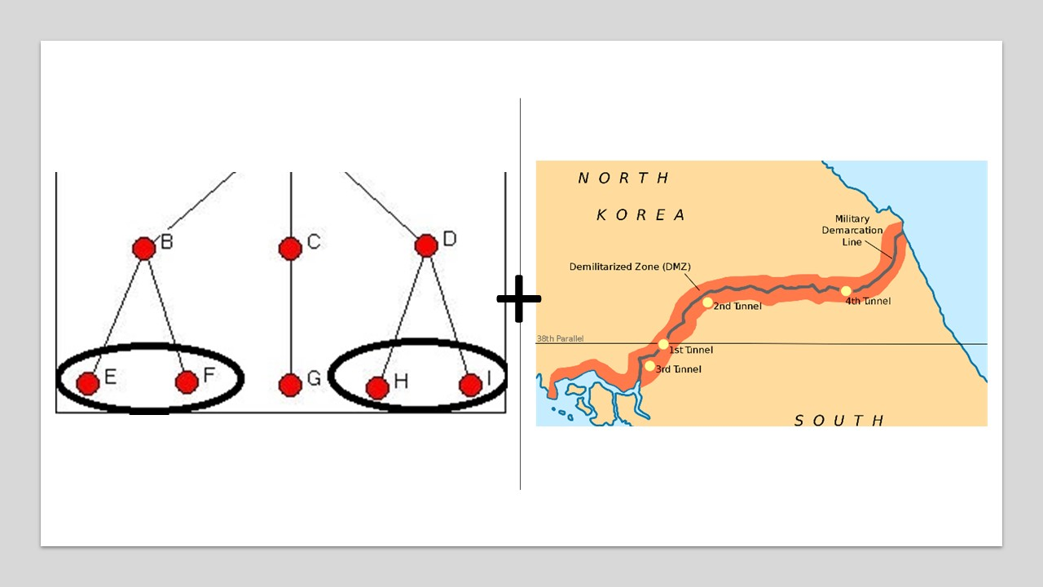

Answer : Equivalence partitioning

1. 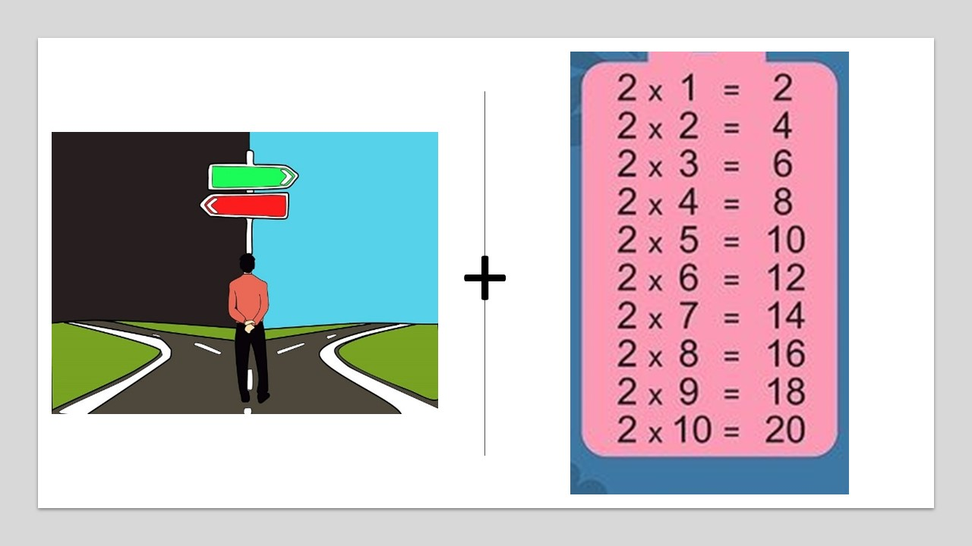

Answer : Decision Table

# Name the activities:

1. 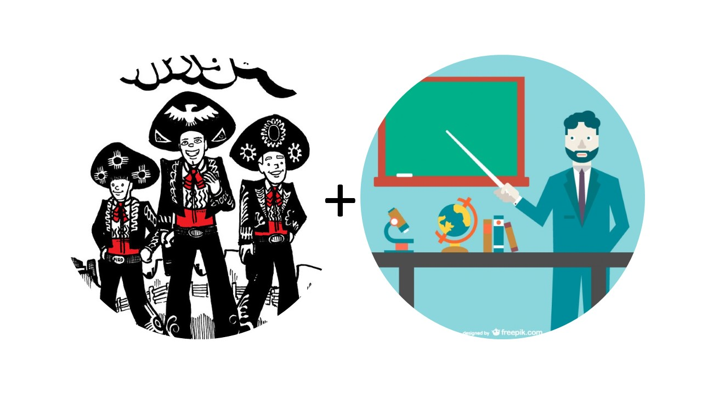

Answer : 3Amigos Session

1. 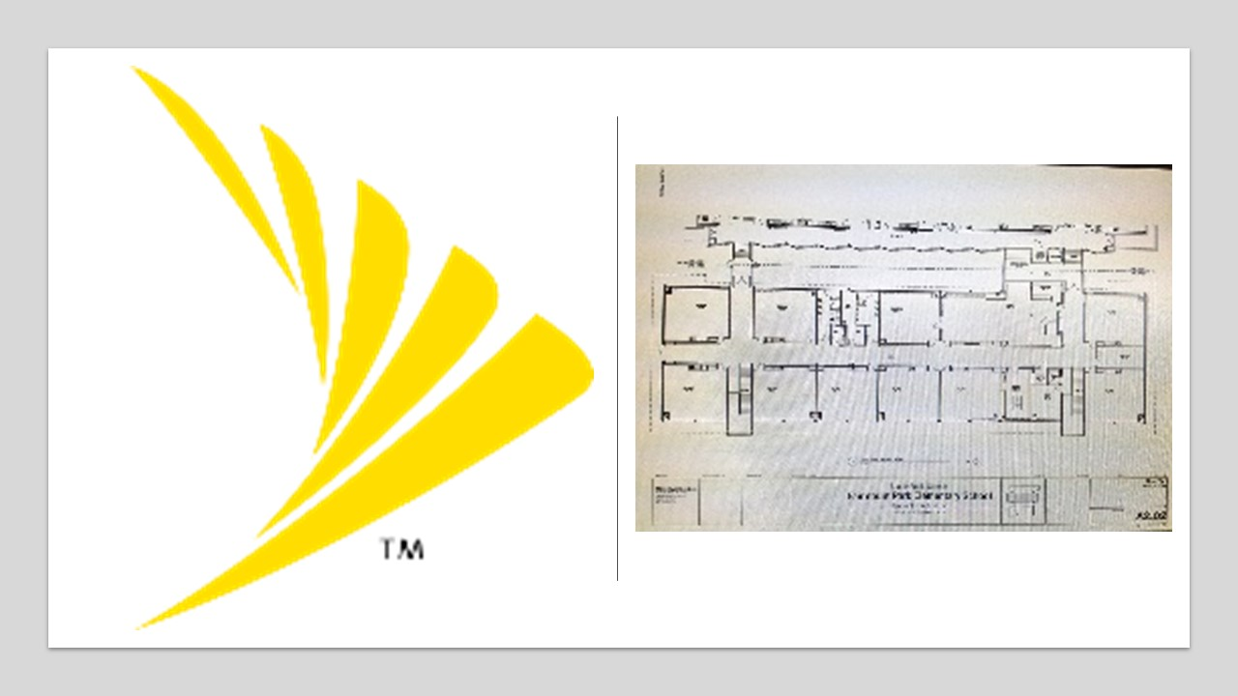

Answer : Sprint Planning

1. 

Answer : Backlog Grooming

# Testing Types:

1. 

Answer : Stress Testing

1. 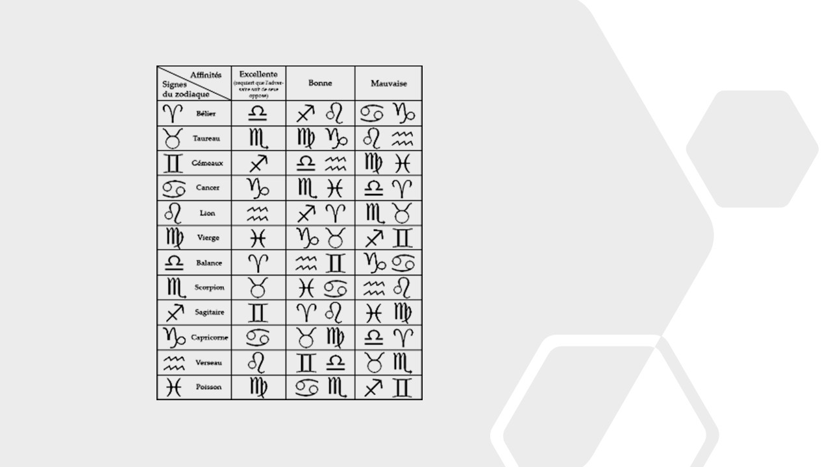

Answer : Compatibility Testing (The image is of Zodiac Signs Compatibility)

1. 

Answer : Exploratory

# Name the Design Patterns:

1. 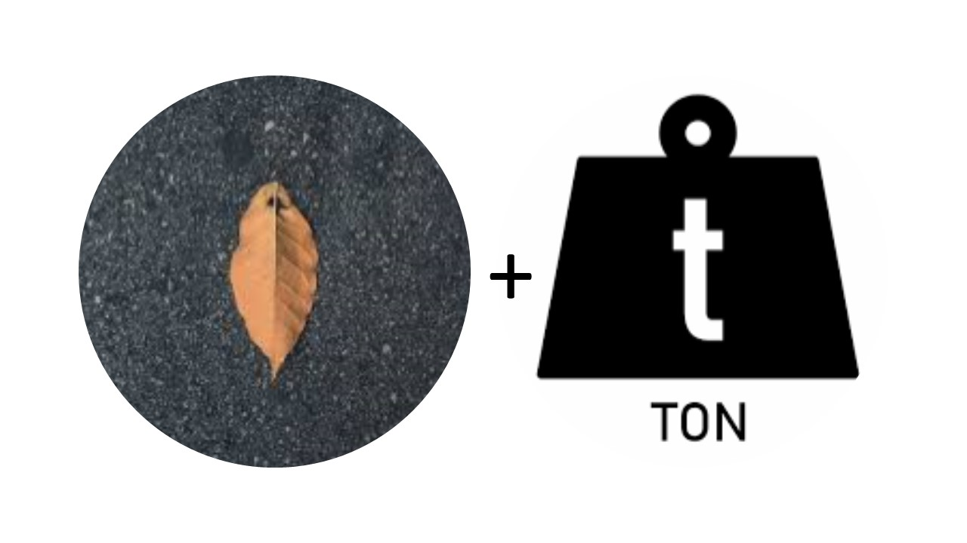

Answer : Singleton

1. 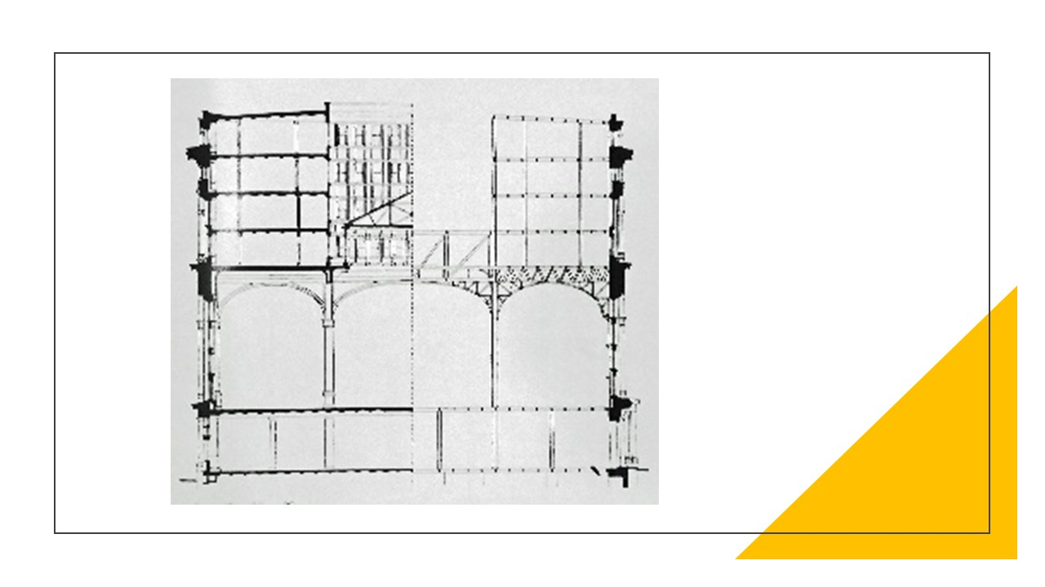

Answer : Structural

1. 

Answer : Factory

# OOPS Concepts

1. 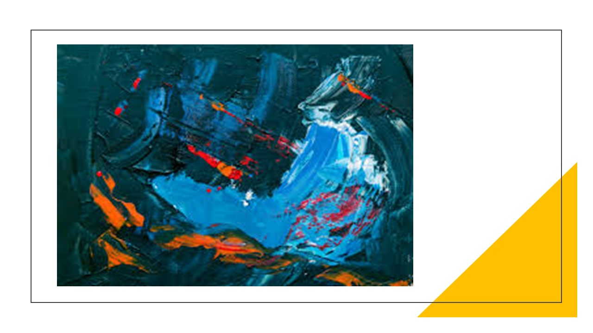

Answer : Abstraction

1. 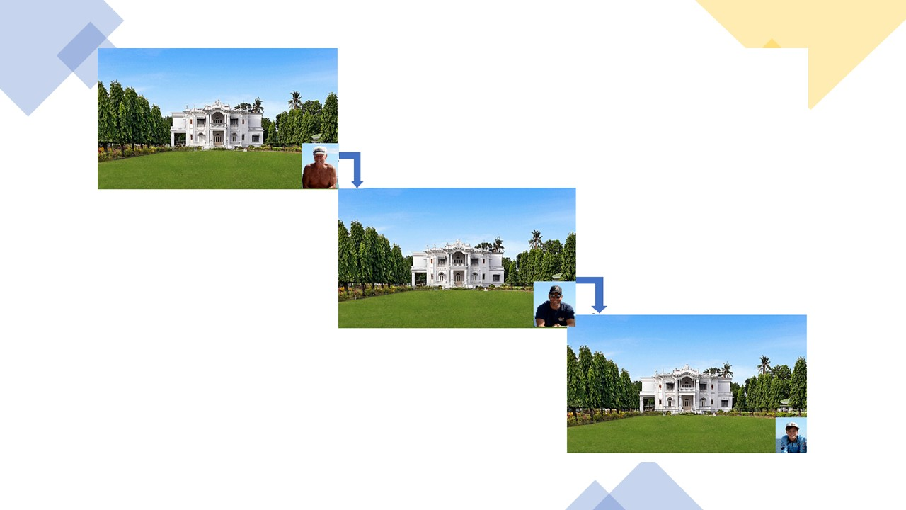

Answer : Inheritance

1. 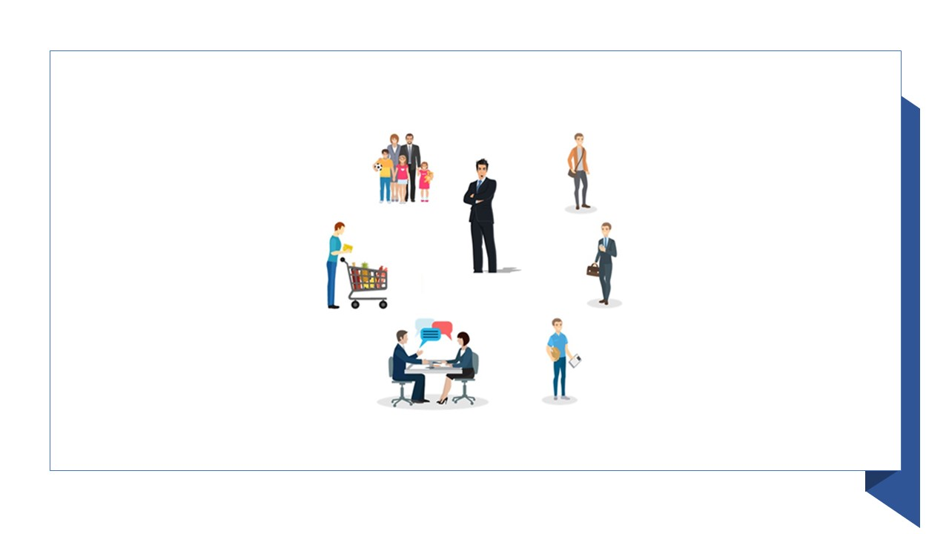

Answer : Polymorphism

# Think Security Testing Terms:

1. 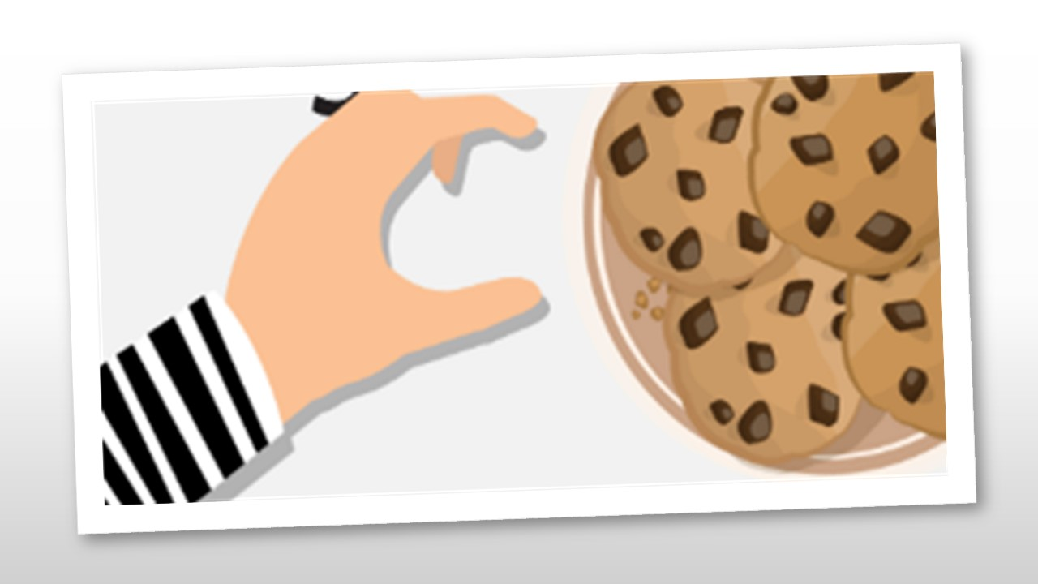

Answer : Session Stealing

1. 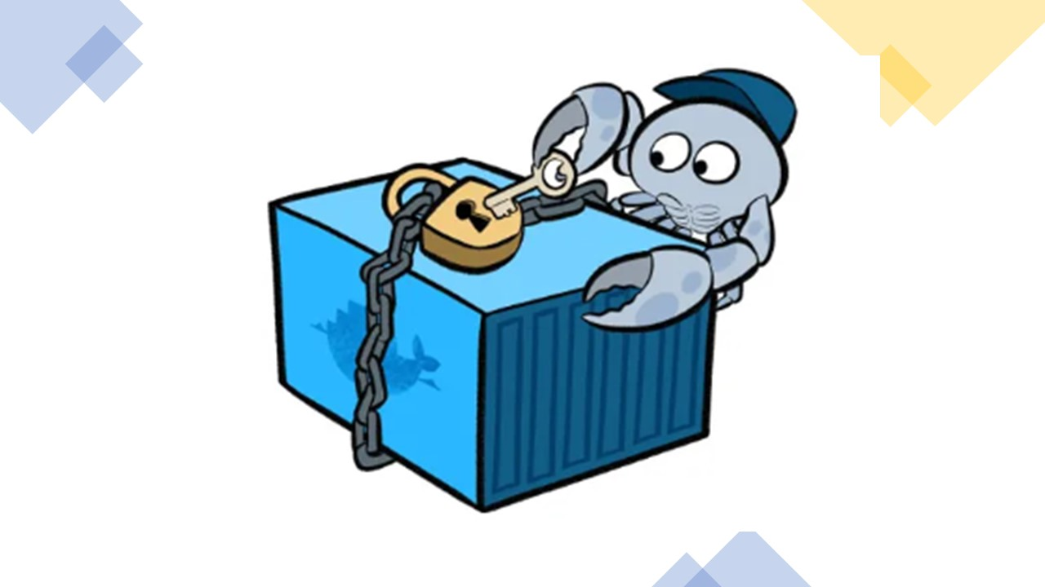

Answer : Docker Security

1. 

Answer : Shoulder Surfing